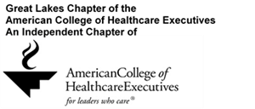
Michigan and Northwest Ohio Regent Awards Nomination Form
Nominee’s Name:Click here to enter text.

Award Category: Early Career Senior Career Faculty Member Student

Why should this nominee receive this award? Click here to enter text.

Your contact information:
Name:
Phone:
Email:

Please complete and return this form by Friday, April 26, 2019 to:
Derk Pronger, FACHE (dpronger@mhc.net) or
Susan Bianchi (sbianchi@mhc.net) or via fax (231) 935-6548

